**KING’S LIFESAVING ERRAND SERVICE**

**ATTENTION**: **Business and Company Owners, Busy Professionals, New Home Buyers, Single Parents, Retirees, Newlyweds and Busy Couples, students**

OUR SERVICES WILL **SIMPLIFY YOUR LIFE**, HELP YOU

**SAVE MONEY** AND **SPEND MORE TIME** WITH

**FAMILY, FRIENDS AND KIDS,**

JUST DON’T LET **TIME** RUIN YOUR **PRECIOUS LIFE.**

  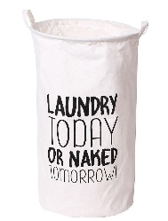

* **Full Laundry services**

**Dry clean pickup and delivery**

* **Pharmacy pickup and delivery**
* **Floral arrangements, Ordering**

**Pick-up and delivery**

* **Meal Service**
* **Gift shopping**
* **Post Office**
* **Transportation services**
* **………………….And so much more……..**

**↓↓ ↓↓ ↓↓ ↓↓ ↓↓**

**CALL 77933878 & 76415785 (Orange) WhatsApp (74239006 & 76079245) FREE CONSULTATION**

**Email:** [**odkmok@gmail.com**](mailto:odkmok@gmail.com) **Mr. O. King Mokone**